**HANGMAN**

Project submitted to the

SRM University – AP, Andhra Pradesh

Submitted in partial fulfillment of the requirement for the award of the degree of

**Bachelor of Technology**

**in**

**Computer Science and Engineering**

**School of Engineering and Sciences**

Submitted By

**PEDDISETTY DURGA MAHESH**

**(AP21110010911)**

Under the guidance of

**Mohammad Miskeen Ali**



**Department of Computer Science and Engineering SRM University, AP**

**Neerukonda, Mangalagiri, Guntur**

**Andhra Pradesh – 522 240**

**[December, 2022]**

**CERTIFICATE**

This is to certify that the Project report entitled **“HANGMAN”** is being submitted by **PEDDISETTY DURGA MAHESH(AP21110010911),** a student of Department of Computer Science and Engineering, SRM University, AP, in partial fulfillment of the requirement for the degree of **“B.Tech(CSE)”**  carried out by her/his during the academic year 2022-2023.

Signature of the Supervisor Signature of Head of the Dept.

**Mohammad Miskeen Ali JATINDRA KUMAR DASH**

**Acknowledgement**

The satisfaction that accompanies the successful completion of any task would be incomplete without introducing the people who made it possible and whose constant guidance and encouragement crowns all efforts with success.

I am extremely grateful and express my profound gratitude and indebtedness to my project guide, **Mr. Mohammad Miskeen Ali**, Lecturer, Department of Computer Science & Engineering, SRM University, Andhra Pradesh, for her kind help and for giving me the necessary guidance and valuable suggestions in completing this project work.

**P.DURGA MAHESH**

**(AP21110010911)**

**ABSTRACT**

**In this project, you will be working with The Hangman Game In Python is written in a python programming language, In this Hangman Game Project is to implement the Hangman Game Using Python. It doesn’t require any specific modules other than random and time. Python loops and functions are enough to build this game here.**

**TABLE OF CONTENTS**

1. Introduction
2. Problem Statement
3. **Concluding Remark**
4. **Future works**
5. Implementation
6. Output
7. References

**INTRODUCTION**

A Hangman Game On Python is about guessing letters (A-Z) to form the words. If the player guesses the right letter that is within the word, the letter appears at its correct position. The user has to guess the correct word until a man is hung, then the game is over.

**PROBLEM STATEMENT**

Hangman is a paper and pencil guessing game for two or more players. One player thinks of a word and the other tries to guess it by suggesting the letters. The word to guess is represented by a row of dashes, giving the number of letters.

**METHODOLOGY**

We use two type of modules they are random and time

We have used different functions they are:

main()

play_loop()

hangman()

choices()

getdetails()

checkdetails()

in both get and checkdetails we used file handiling

and we used loops in this project

**CONCLUDING REMARK:**

With this project, we can conclude that this project is very helpful for people to play hangman game in there free time. I this we learned different types modules and

By doing this project we are perfect in the concepts like decision making statements, functions.

**FUUTURE WORKS:**

Our future work would be designing more complex ,entertaining and challenging games.it would also be designing some interesting apps.

**IMPLEMENTATION**

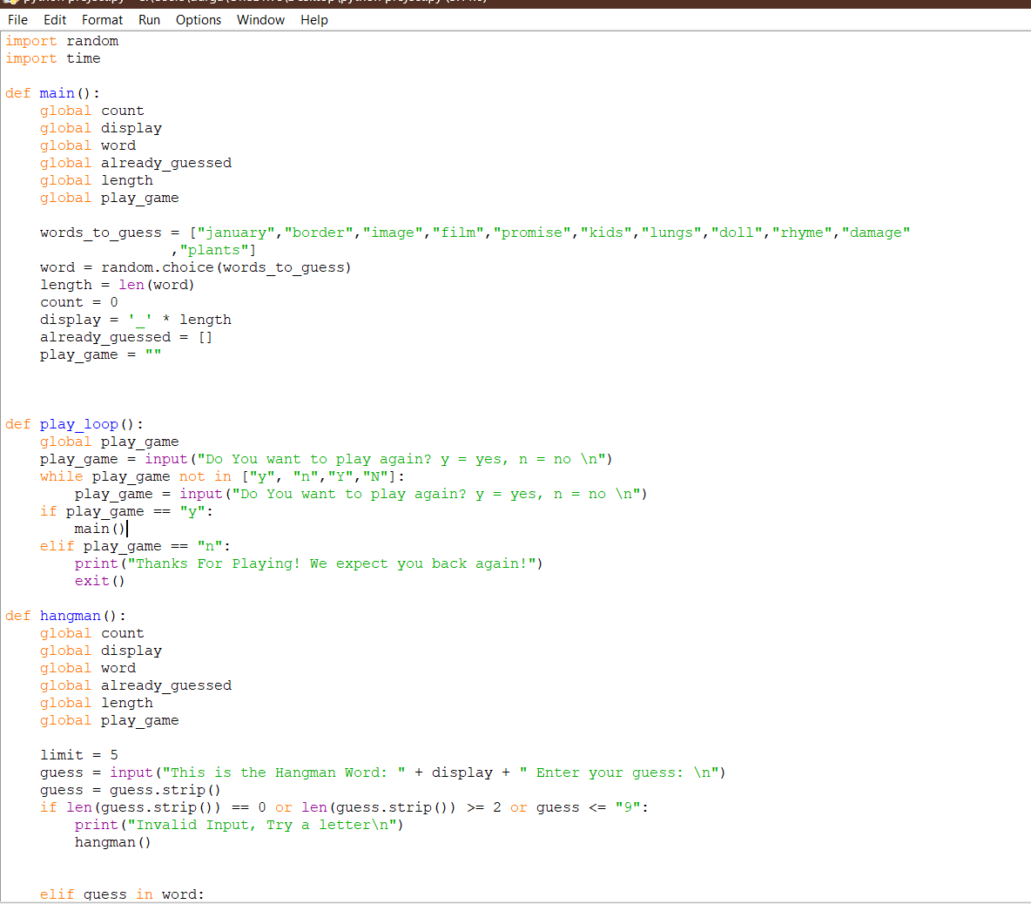

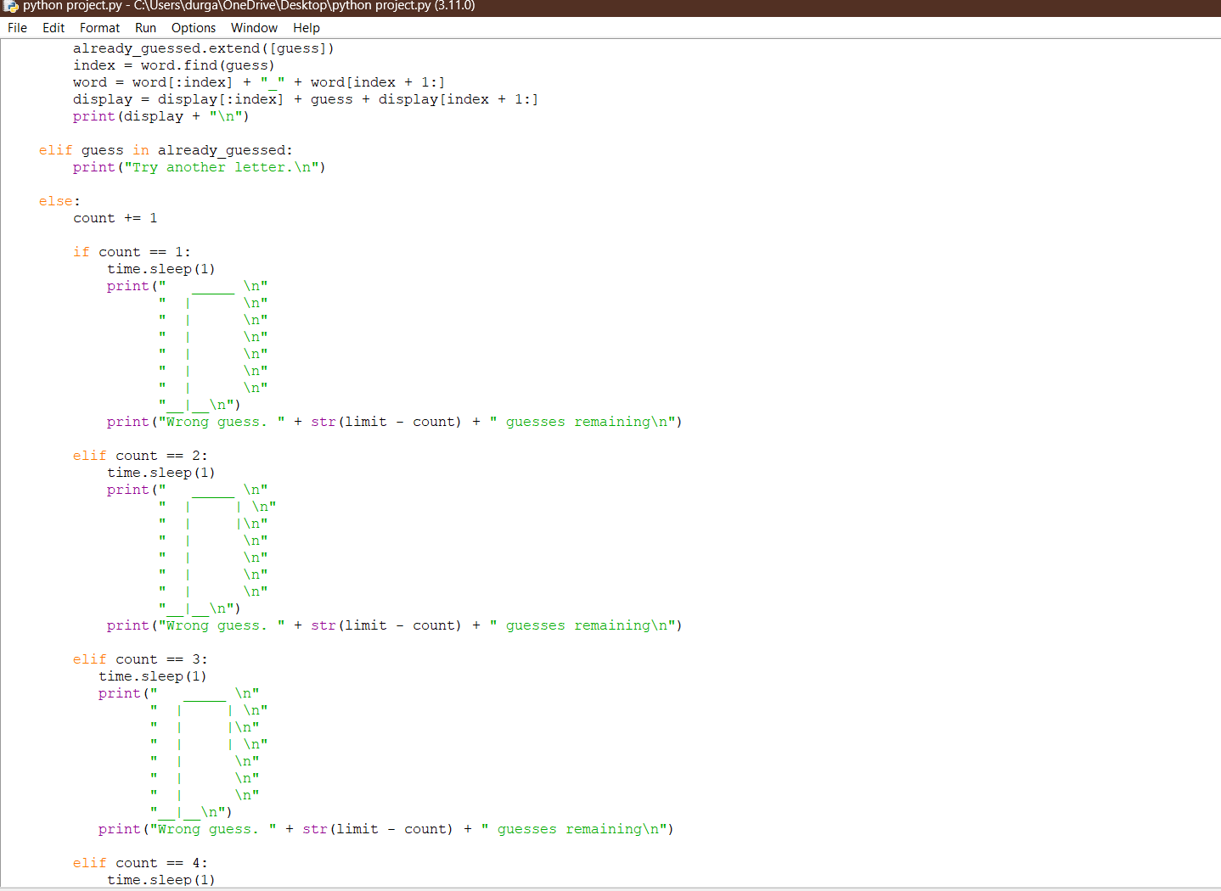

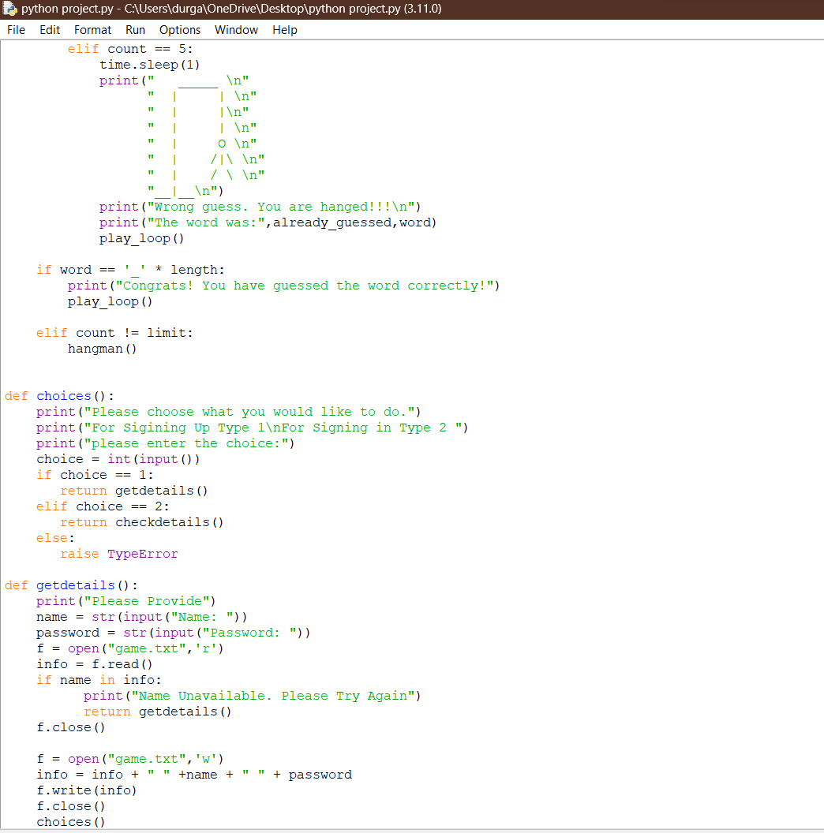

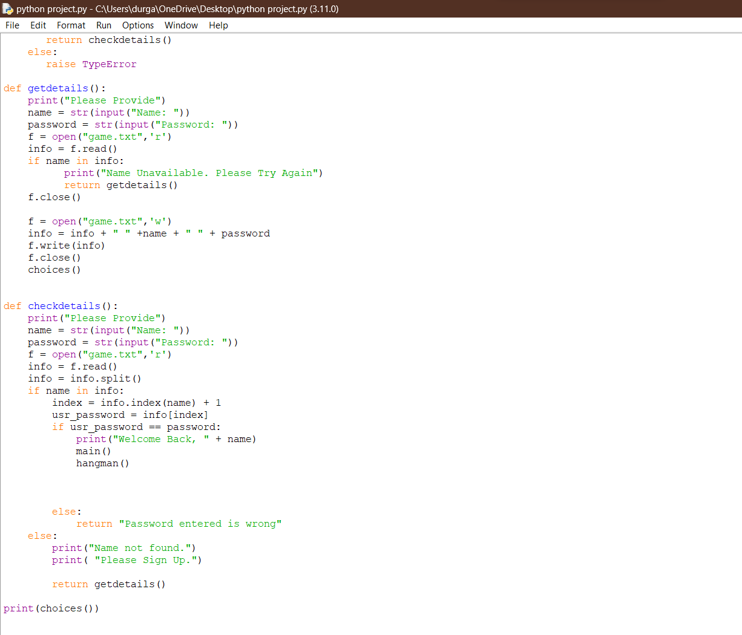

**OUTPUT**

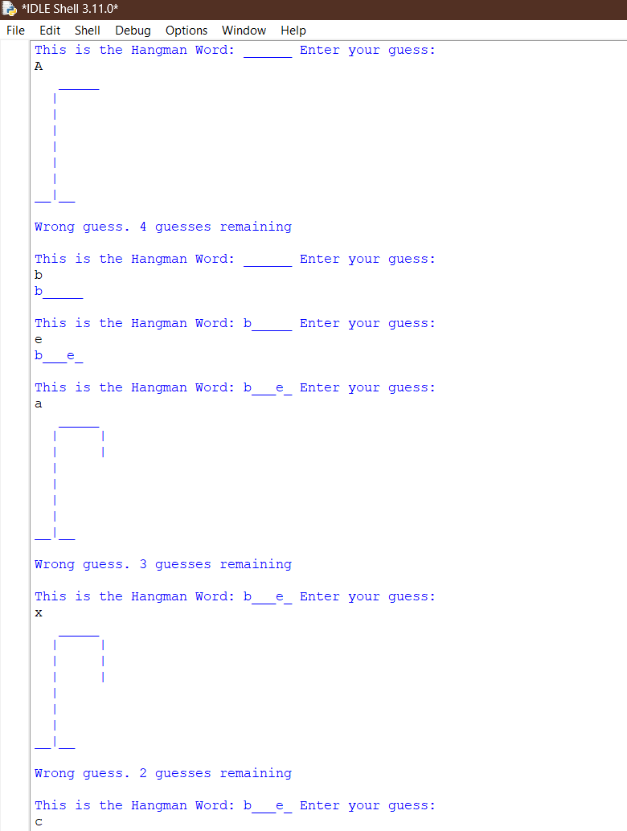

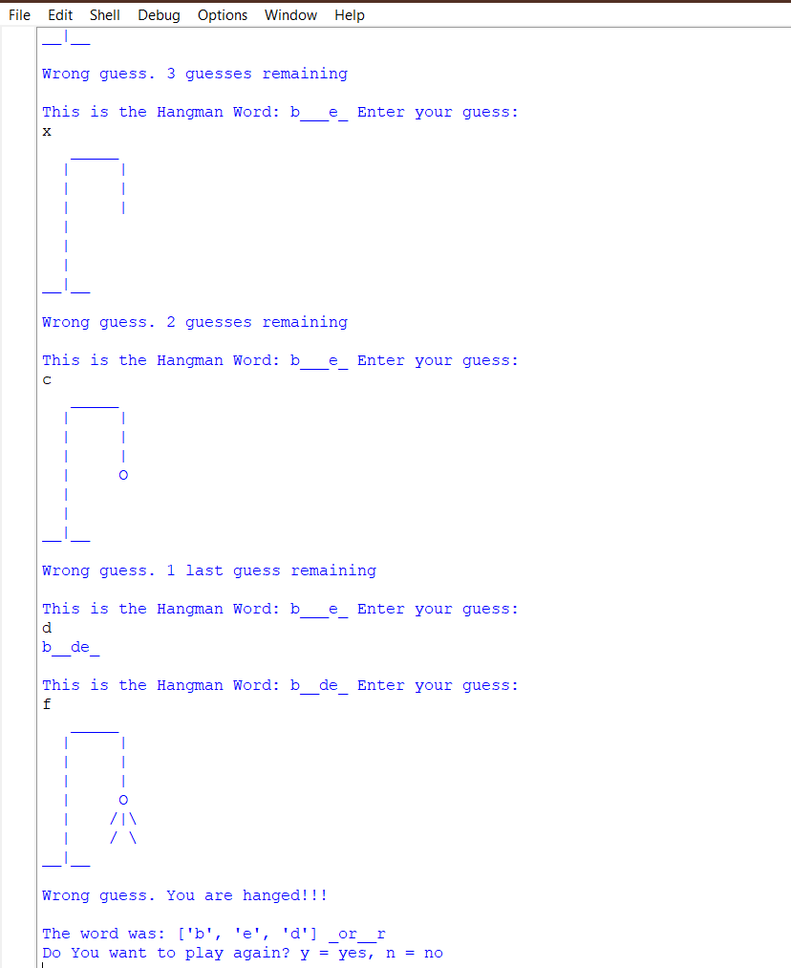

**REFERENCE:**

GeeksforGeeks.com

Wordsearch.com

W3resource.com